Connected Camp Parent Consent & Agreement Forms
______________________________________________________________________
Connected Life Christian Church is excited to invite your child to participate in Connected Camp, a summer day camp designed to provide a fun, safe, and engaging environment for children to grow, learn, and build meaningful relationships. Connected Camp offers a variety of activities including non-competitive sports, science projects, arts and crafts, and interactive theater, all while fostering community and positive character development.
All children attending Connected Camp are required to be registered with Connected Life Christian Church and must have a signed parent or legal guardian consent form on file prior to participation. These forms are necessary to ensure the safety, well-being, and proper care of each camper throughout the program.
Attached are the required parent consent, refund policy acknowledgment, photo release, and permission-to-contact forms for Connected Camp. Please carefully review each section, provide initials where indicated, and sign the consent page at the end of the packet.
Thank you for allowing us the opportunity to care for and invest in your child this summer. If you have any questions or need additional information, please feel free to reach out.
Sincerely,
Nhu Nguyen, Lead Pastor Talia Stacy, Children’s Outreach Coordinator

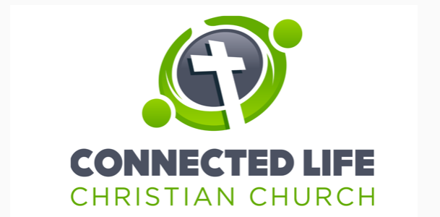

Connected Camp is operated by Connected Life Christian Church. Please carefully read each section below. Parent/Legal Guardian initials and signature are required.

Parent Statement
I understand that Connected Camp, operated by Connected Life Christian Church, includes indoor and outdoor activities that may involve inherent risks, including the possibility of accidental injury, despite reasonable precautions and supervision. As the parent or legal guardian of the registered camper(s), I give permission for my child(ren) to participate in all camp activities, including but not limited to non-competitive sports, science projects, arts and crafts, and interactive theater. I acknowledge these risks and voluntarily assume responsibility for my child’s participation. I hereby release and hold harmless Connected Life Christian Church, its board members, staff, officers, volunteers, and agents, from liability for injury, loss, or damage arising from participation in Connected Camp activities, to the fullest extent permitted by law, including claims of negligence or negligent supervision. I further understand that Connected Life Christian Church is not responsible for lost, stolen, or damaged personal property brought to camp, and I agree to be financially responsible for any damage caused by my child to church property. I also consent to being contacted by phone, email, or text regarding
camp-related updates. I understand that my contact information will be used solely for camp communication and will not be shared with outside parties.

Parent/Legal Guardian Initials: ____________________

Refund Policy Statement
I understand and agree to the following refund policy for Connected Camp, operated by Connected Life Christian Church. Refunds may be requested up until June 1. After June 1, no refunds will be issued for any reason, including missed days, schedule changes, illness, early withdrawal, disciplinary dismissal, weather-related closures, or other unforeseen circumstances. Because camp registration is priced by the week, unused days do not roll over and cannot be credited or refunded. Make-up days are not available. I acknowledge that once registration is submitted and payment is processed, staffing, supplies, and planning commitments are made, and camp fees become non-refundable after June 1.

Parent/Legal Guardian Initials: ____________________

Photo Release
I grant permission for Connected Life Christian Church, including its board members, employees, volunteers, and agents, to photograph or record my child during Connected Camp activities. I understand that these images or recordings may be used without compensation for promotional purposes, including the church website, social media, printed materials, and other communications related to Connected Camp.

Parent/Legal Guardian Initials: ____________________

Permission to Contact
Connected Camp, operated by Connected Life Christian Church, is hereby granted permission to contact me via phone, email, or text in regards to camp updates or changes, special events, or emergency information. I understand that my personal contact information will only be used for camp purposes and will not be distributed or shared with outside companies.

Parent/Legal Guardian Initials: ____________________

Consent Signature
By signing below, I acknowledge that I have read and agree to all sections of the Connected Camp including: Parent Statement, Refund Policy Statement, Photo Release, and Permission to Contact, and that you give your consent to each section for your student. Thank you.

Parent/Legal Guardian Signature:

Child(ren) Name(s): ______________________________________________________

_______________________________________________________________________

Parent/Guardian Name (Full-name Print):

______________________________________________
Signature (Full-name): ______________________________________________

Date (mm/dd/yyyy): _________________________

